2025



|  |  |
| --- | --- |
| Name | Muhammad Taha Jamal |
| Registration Id | 2112244 |
| Section | BSCS 8th A |
| Course | Introduction to DevOps |
| Instructor | Tariq Khan Ghouri |

**DevOps**

**LAB02**

By Umer Amir _ 2112241

M. Taha Jamal _ 2112244

**TASK 1:**

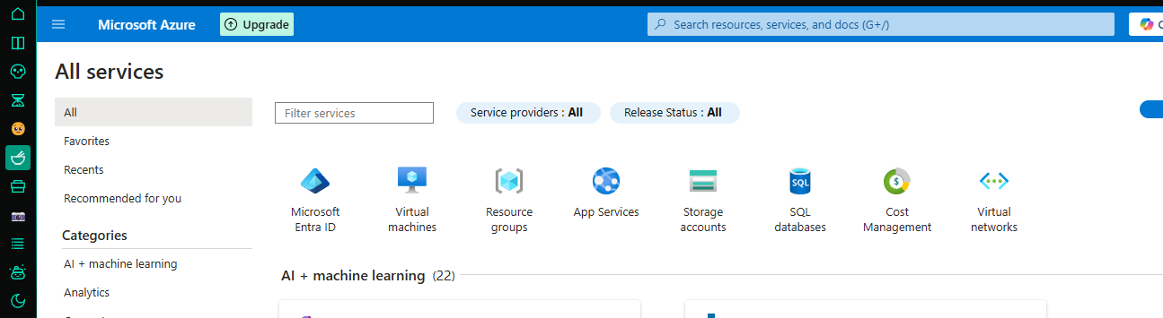 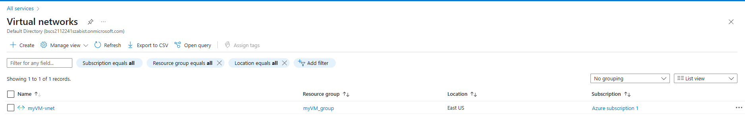 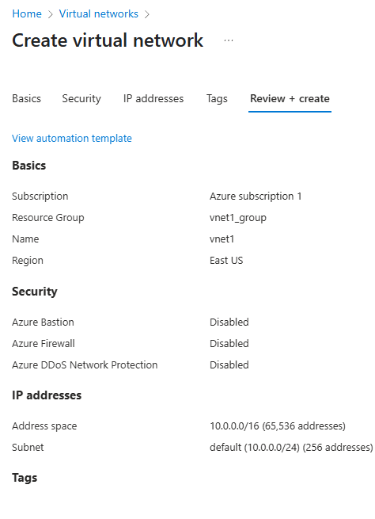 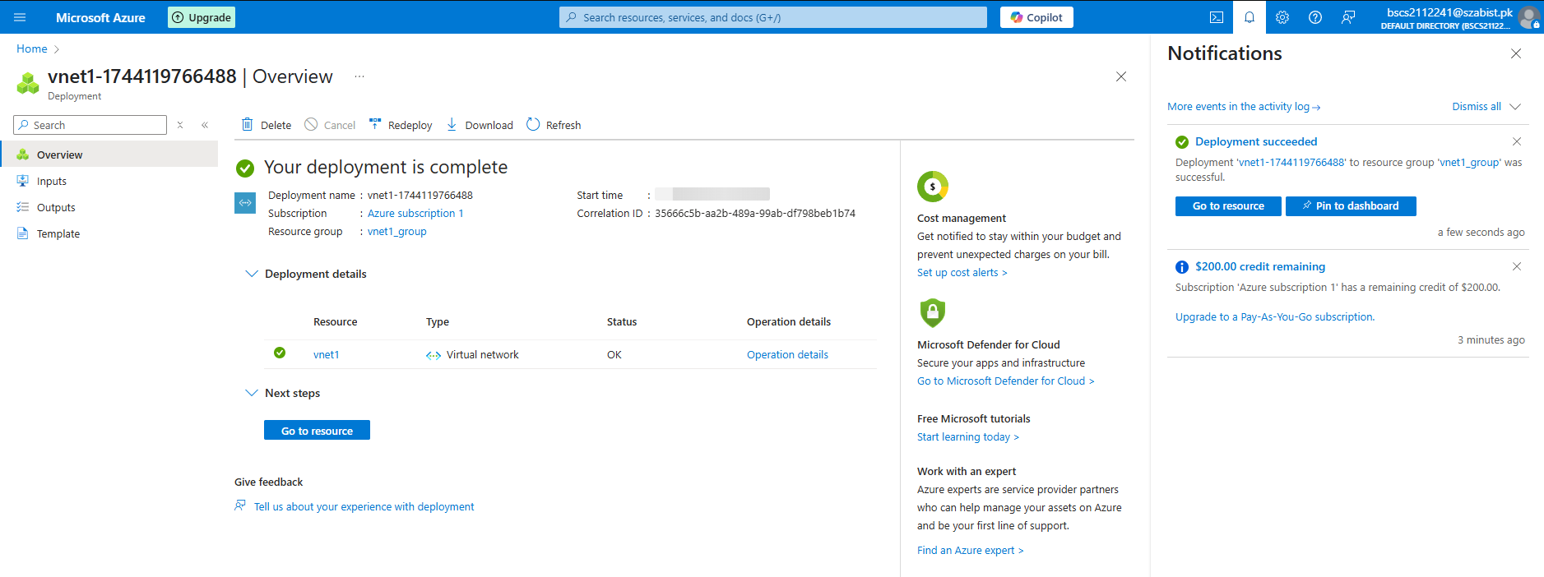

**TASK 2:** 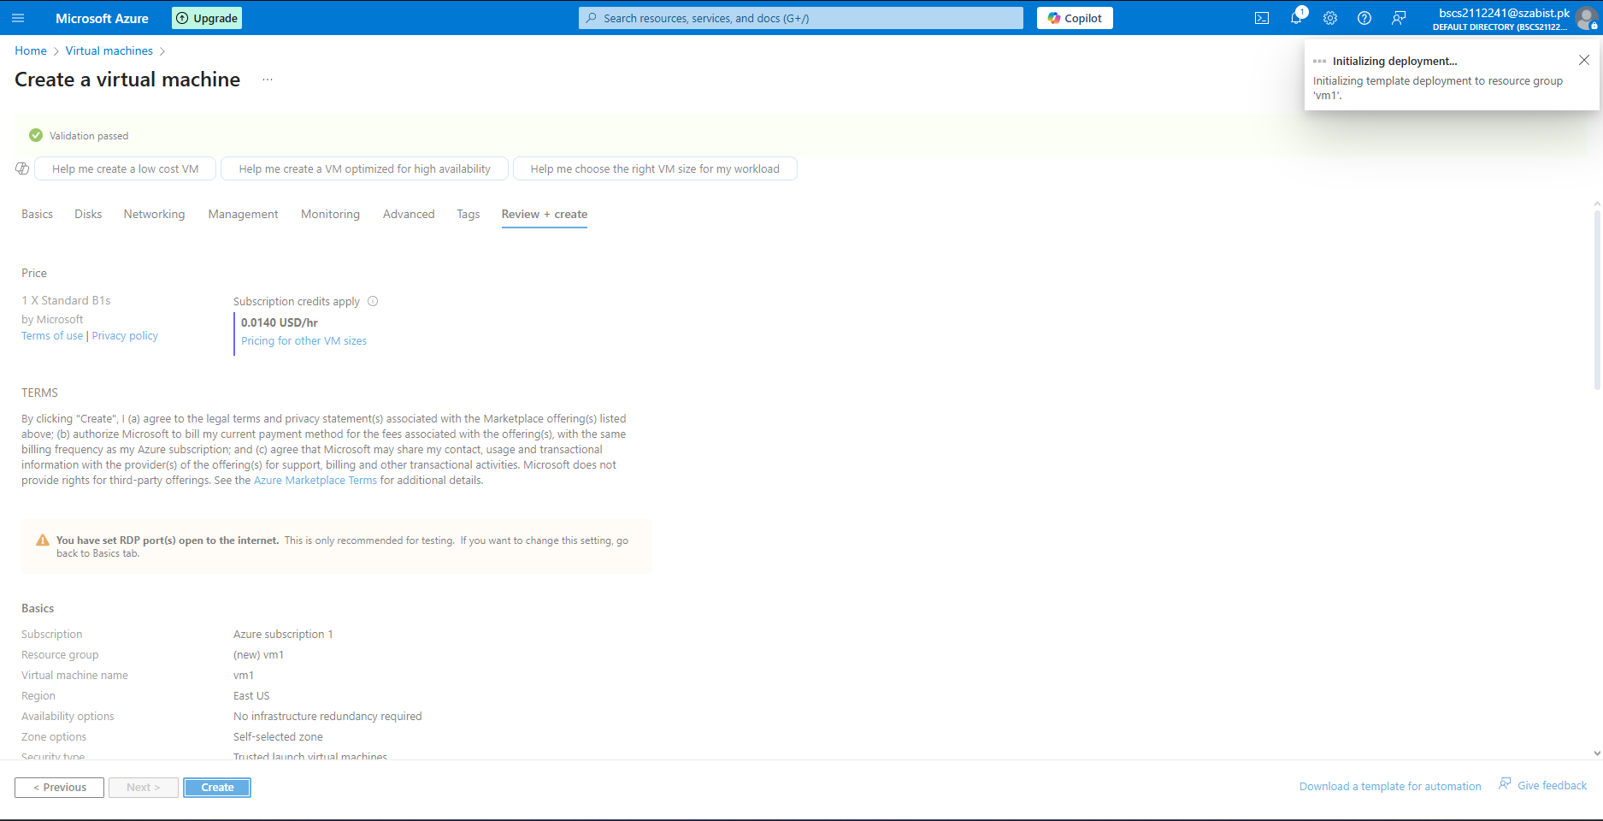 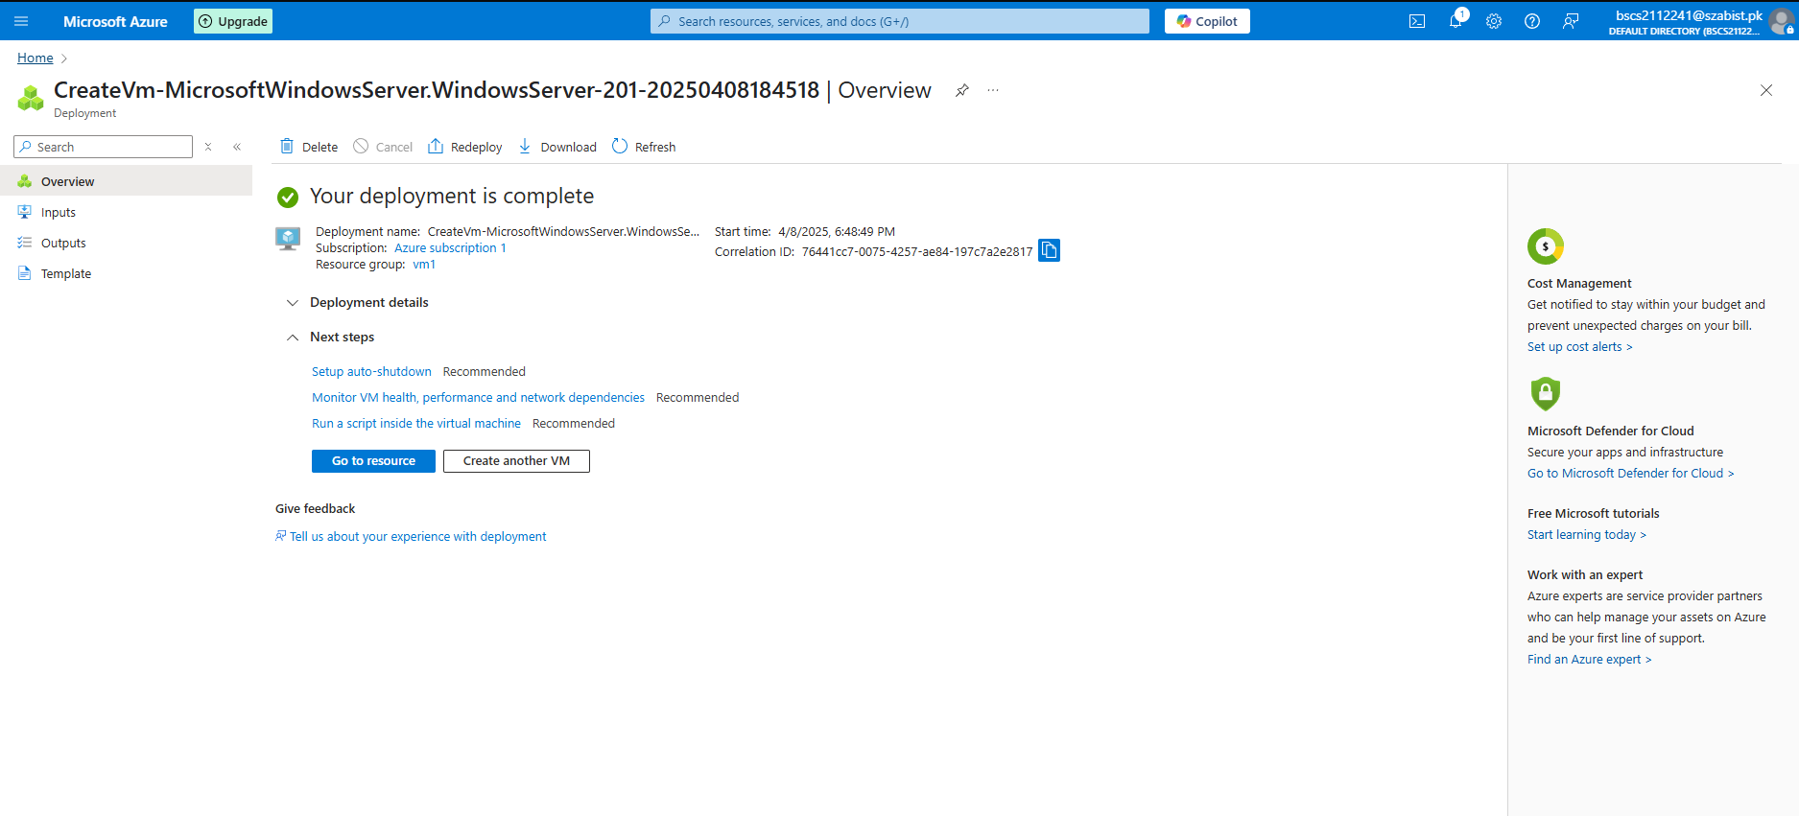 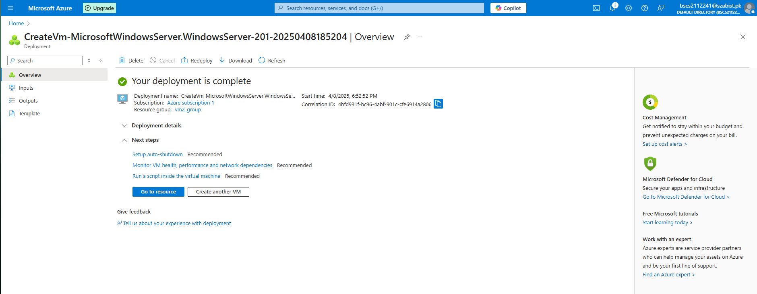

**TASK 3:**

 